Canberra's most complained-about, compliance-breaching childcare centre still 'exceeding' standards

By Lanie Tindale, Canberra Times
Updated October 6 2025
A full list of complaints and compliance breaches is at the bottom of this article.
A website for Edge Early Learning Charnwood boasts that, alongside an "amazing in-house chef" and veggie garden, the childcare centre exceeds national quality standards.
But in only two years, the service breached child safety laws seven times and was subject to dozens of complaints.
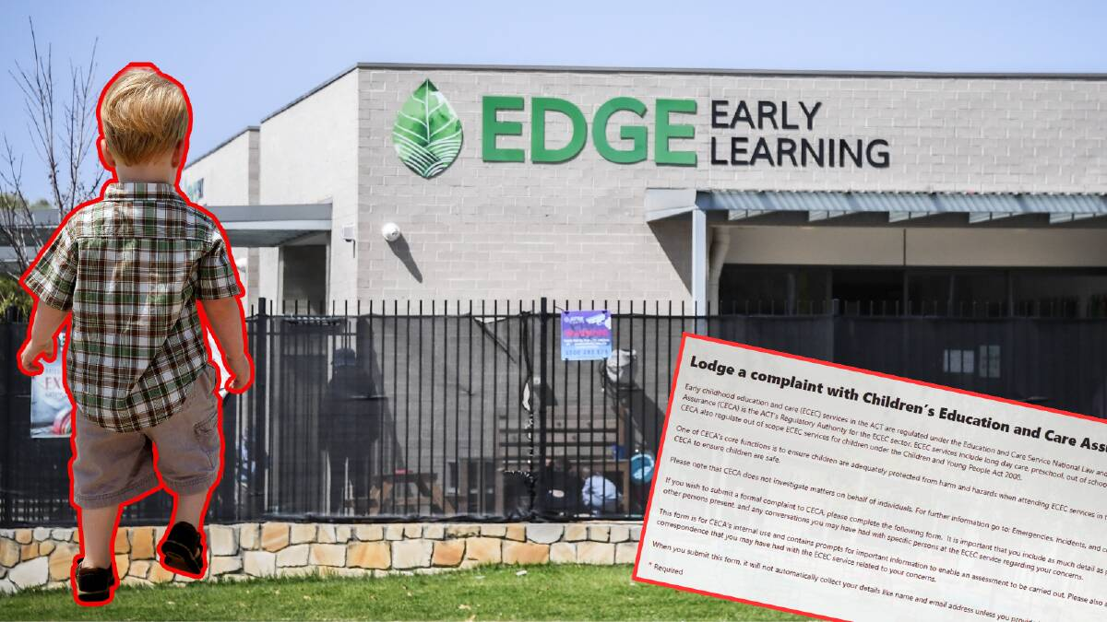
Edge Early Learning Charnwood. Picture by Karleen Minney
It is one of a few Canberra childcare and after-school centres that maintain high ratings despite breaching child safety laws or being formally complained about.
The ACT childcare regulator issued about 175 compliance actions against a third of Canberra's childcare and after-school centres in the two years between March 18, 2023 and 2025, documents released under freedom-of-information laws show.
In that time, Children's Education and Care Assurance (CECA) also received about 750 formal complaints about services.
While The Canberra Times does not know the exact nature of breaches or complaints, the regulator investigated allegations of inappropriate discipline or interactions with children, missing children and inadequate supervision in 2023-24.
Canberra's most complained-about childcare centre
Edge Early Learning Charnwood was assessed as exceeding National Quality Standards in August 2022, the second-highest rating a centre can achieve.
The rating remains despite the regulator issuing the centre seven compliance actions. It was also subject to more complaints, about 20, than any other service.
Edge Early Learning did not respond to requests to comment.
Centres with most breaches
- Edge Early Learning Charnwood
- Bright Future Early Learning
- Genius Gungahlin
- Guardian Childcare & Education Forrest
- Bright Buds Early Learning Centre
- Communities@Work Palmerston Out of School Hours Care
- Edge Early Learning Higgins
- Gold Creek World of Learning
The regulator can issue a compliance action if it decides a childcare or after-school centre has breached child safety laws.
The same body issues ratings to early learning centres, ranging from "significant improvement needed" to "excellent". As of June 2024, only one centre was rated as excellent.
Childcare centre ratings ACT as of June 2024
- Significant improvement needed: 1
- Working towards National Quality Standards: 53 (15 per cent)
- Meeting National Quality Standards: 139 (40 per cent)
- Exceeding National Quality Standards: 154 (44 per cent)
- Excellent: 1
- Source: ACEQCA annual report 2023-24
The spokesman said a rating is issued after a thorough assessment that can take up to 20 weeks.
"An identified breach does not trigger a re-assessment, nor is one required [by law]," he said.
It assessed and issued a rating to 50 of the ACT's 377 services in 2023-24.
After school care company commits to improvement
Communities@Work Palmerston Out of School Hours Care is also considered to be exceeding standards despite four compliance breaches and about five complaints in two years.
Communities@Work after-school services in Bonython, Charles Weston, Emmaus, Fadden, Maribyrnong, Monash, Neville Bonner, Stirling and Mount Rogers schools all breached compliance laws.
Communities@Work said it is "committed to fostering a culture of transparency, accountability, and continuous improvement" and recognise complaints as "a key mechanism for identifying opportunities to strengthen our services".
A spokeswoman said it prioritises child safety and encourage a healthy reporting culture so staff and families feel empowered to raise concerns.
"We co-operate fully with regulators, and all issued actions have been resolved," they said.
Inappropriate discipline, missing children
The ACT regulator received more than 10 formal complaints about 18 services.
Anyone can make a complaint to the watchdog about any service. It is different to a report, which is when an educator or provider notifies the regulator of any incident or illness.
Guardian Childcare & Education Wanniassa, Busy Bees at Crace, Forrest Early Education and Care Centre, Genius Gungahlin and Guardian Childcare & Education Bruce were the subject of a high volume of complaints.
Most complained about centres
- Edge Early Learning Charnwood
- Guardian Childcare & Education Wanniassa
- Busy Bees at Crace
- Forrest Early Education and Care Centre
- Genius Gungahlin
- Guardian Childcare & Education Bruce
- Guardian Childcare & Education Forrest
- Gungahlin Montessori Academy
- Wonderschool Conder
- Edge Early Learning Ngunnawal
- YWCA Charles Conder School Age Care
- Bright Future Early Learning
- Springbank Rise by Busy Bees
- Bright Buds Early Learning Centre

The Canberra Times does not know the nature of those complaints or whether they were resolved.
A CECA spokesman said parents can request information from their provider about complaints and breaches.
"Parents are entitled to ask for a copy of a service's compliance record. Parents may also ask for the number of complaints and notifications made by a service or provider," he said.
The regulator carried out 177 audits on childcare centres in 2023-24, including 14 requiring a rapid response. It commenced 69 investigations.
"Major areas of investigation during 2023-24 were allegations of inappropriate discipline or interactions with children, inadequate supervision, and missing or unaccounted for children," the Education Directorate 2023-24 annual report said.
"There was a significant increase in the number of investigations about educator interactions with children."
Starting blocks
Childcare centres have been in the spotlight since a Victorian educator was charged with sexually abusing dozens of children in May.
In response to safety concerns, the federal government started publishing information about conditions imposed on childcare centres on a new national website, Starting Blocks.
More detailed information will begin to be published in November.
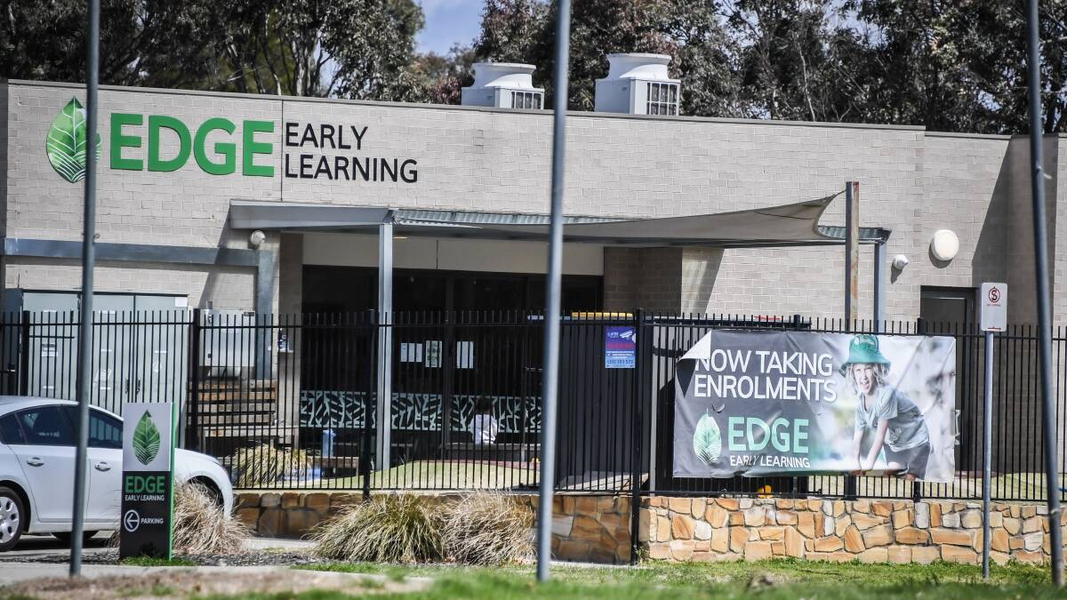
Edge Early Learning Centre Charnwood. Picture by Karleen Minney
The website shows that some Canberra services were subject to conditions as of September 25.
Busy Bees in Oxley had to roster two additional educators and have two carers working directly with children in each room to ensure adequate supervision.
Gungahlin Montessori Academy was subject to four conditions, including ensuring no more than 20 children under 15 months attend the service at any one time, limited by the number of cots available and the ability of educators to carry them during an evacuation.
READ MORE:
- Fight to save Belconnen's SDN Bluebell centre continues
- Children over shareholders': sector grilled for lapses
- How Australia's childcare safety crisis unfolded
Search to find compliance actions, complaints
Read More:

